Ryan Ellis
COSC 320 --- 001 Lab 6 3/11/2025

Lab report: In this lab, we were given the header file d_state.h for the stateCity class structure and were asked to write two programs: one to implement the STL set library and include the stateCity class structure, and another to implement the STL map library to prompt the user for a string “state” input and check to see if the input was apart of the set or map. This lab took me about 1 hour to complete cumulatively.

Pre-lab:
- Review the contents we learned about set and map.

Lab 3.1

Exercise 1:
Header file (d_state.h)
#ifndef STATECITY_CLASS
#define STATECITY_CLASS

#include <iostream>
#include <string>

using namespace std;

// object stores the state name and city in the state
class stateCity
{
public:
stateCity (const string& name = "", const string& city = "");

// output the state and city name in the format
// cityName, stateName
friend ostream& operator<< (ostream& ostr, const stateCity& state);

// operators < and == must be defined to use with set object.
// operators use only the stateName as the key
friend bool operator< (const stateCity& a, const stateCity& b);

friend bool operator== (const stateCity& a, const stateCity& b);

private:
string stateName, cityName;
};

#endif // STATECITY_CLASS

//====================================================
// Description: Constructor for the stateCity class structure, sets
// the passed parameters to the private values of the city and state name.
//====================================================
stateCity :: stateCity(const string &name, const string &city){
stateName = name;
cityName = city;
}

//====================================================
// Description: Overloaded stream operator for the stateCity class structure,
// which will output the city and state name in a formatted output.
//====================================================
ostream &operator<<(ostream &ostr, const stateCity& state){
ostr<< state.cityName <<", "<<state.stateName<<endl;
return ostr;
}

//====================================================
// Description: Overloaded equivalency operator for the stateCity class
// structure, which returns a true boolean value if the two states are
// equivalent.
//====================================================
bool operator==(const stateCity &a, const stateCity &b){
bool status;

if(a.stateName == b.stateName)
status = true;
else
status = false;
return status;
}

//====================================================
// Description: Overloaded less than operator for the stateCity class
// structure, which returns a true boolean value if the left state
// is less than the right state.
//====================================================
bool operator< (const stateCity &a, const stateCity &b){
bool status;

if(a.stateName < b.stateName)
status = true;
else
status = false;
return status;

}

Implementation File (lab06_set.cpp)
//================================================================
// Filename: lab06_set.cpp
// Author: Ryan Ellis
// Creation Date: 3/11/2025
// Last Update: 3/11/2025
// Description: Main program that implements STL set and stateCity class structure that builds a set of
// stateCity objects and prompts the user for a state and searches the set and returns if it is found or not.
//================================================================

#include <iostream>
#include <set>
#include "d_state.h"

using namespace std;

int main(){

set<stateCity> s;
set<stateCity>::iterator pos; //define set and iterator

stateCity md("Maryland", "Salisbury"); //define stateCity objects
stateCity de("Delaware", "Wilmington");
stateCity tx("Texas", "Austin");
stateCity fl("Florida", "Miami");
stateCity md1("Pennsylvania", "York");

string input; //user input

s.insert(md); //insert set with stateCity objects
s.insert(de);
s.insert(tx);
s.insert(fl);
s.insert(md1);

cout<<"Enter a state: "; //prompt for user input
cin>> input;

stateCity flag(input, ""); //set input as flag for search

pos = s.find(flag); //set iterator for flag

if(pos != s.end()) //if iterator isn't pointing at end of set it's found
cout<< *pos;
else
cout<<input <<" was not found"<<endl; //otherwise it's not found

return 0;
}

Output:
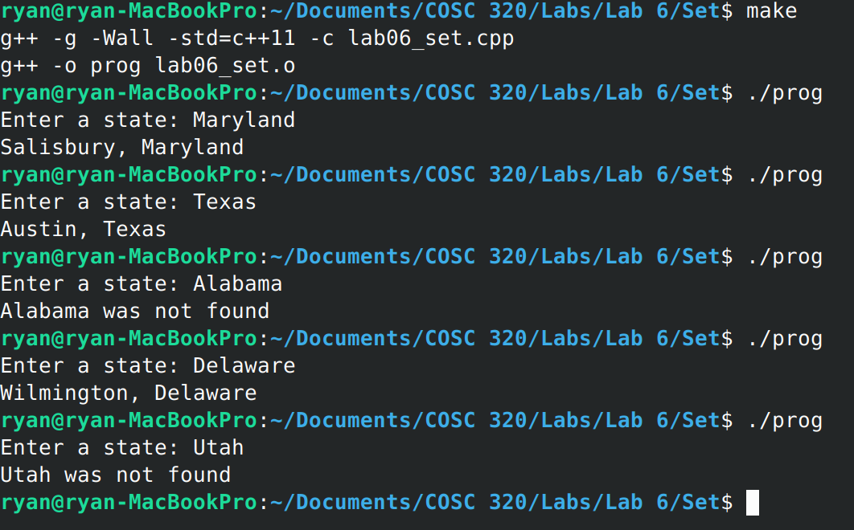

Exercise 2:
//================================================================
// Filename: lab06_map.cpp
// Author: Ryan Ellis
// Creation Date: 3/11/2025
// Last Update: 3/11/2025
// Description: Main program that implements STL map structure that builds a map of
// key and data values using strings for state and city names, then prompts the user for a state and searches
// the map and returns if it is found or not.
//================================================================

#include <iostream>
#include <map>
#include "d_state.h"

using namespace std;

int main(){
map<string, string> m; //define map and iterator
map<string, string> ::iterator miter;

m["Maryland"] = "Salisbury"; //populate map with city, state names
m["Delaware"] = "Wilmington";
m["Florida"] = "Miami";
m["Tennessee"] = "Knoxville";
m["Pennsylvania"] = "Philadelphia";

string input; //user input

cout<<"Enter a state: "; //prompt for user input
cin>>input;

miter = m.find(input); //
if(miter != m.end())
cout<<miter->second<<", "<<miter->first<<endl;
else
cout<<input<< " was not found."<<endl;

return 0;
}

Output:
